**💊 Personalized Medicine Recommendation System – Explanation Sheet**

**🧠 Project Idea:**

This project is a **smart medicine suggestion system** that takes a user’s medical condition (like *cold*, *depression*, etc.) and returns a list of **recommended medicines** based on what has worked for similar conditions.

**🧾 Tools and Technologies Used:**

| **Tool** | **Purpose** |
| --- | --- |
| **Python** | Main programming language |
| **Pandas** | Handling the dataset |
| **spaCy** | Natural Language Processing (NLP) to understand text meaning |
| **FastAPI** | Backend framework to create APIs |
| **HTML/CSS** | Frontend user interface |
| **Uvicorn** | Runs the FastAPI backend server |
| **Jupyter Notebook** | For development and testing the model |

**📊 Dataset Used:**

* **Source:** Kaggle (drugsComTrain_raw.csv)
* **Contains:**
  + drugName (e.g., Benadryl)
  + condition (e.g., Cold)
  + review (user feedback)
  + rating, usefulCount

**🔍 Project Workflow (Step-by-Step):**

**1. Data Preprocessing:**

* Remove missing values
* Group drugs by condition
* Create a simplified table with:
  + condition
  + top-rated medicine for each condition

**2. Understanding Text with NLP (spaCy):**

* Load en_core_web_md (medium model with word vectors)
* Convert user input condition into a **vector**
* Compare this vector with all known conditions in the dataset
* Use **cosine similarity** to find the **most similar known condition**

**3. Generate Recommendations:**

* After finding the best-matching known condition,
* Recommend **top medicines** used for that condition from the dataset

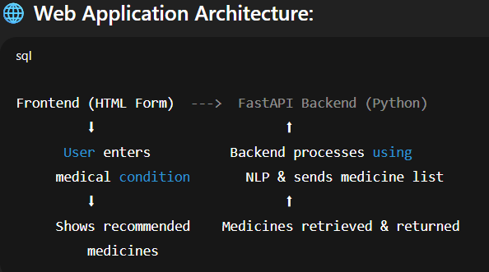

**🖥️ Frontend UI:**

* Simple HTML page with:
  + Input box: “Enter your condition”
  + Submit button
  + Display of recommended medicines

**⚙️ Backend API (FastAPI):**

* **Route 1:** / → Shows the form (HTML page)
* **Route 2:** /recommend → Accepts user input, returns suggestions